|  |
| --- |
| The Role of Artificial Intelligence in Business Operations FAST NUCES – KARACHIName: Talha Mahboob ID: 24K-2556 |
|  |



**Table of Contents**

1. Introduction
2. AI in Customer Service
3. AI in Operations Management
4. AI in Data Analysis and Decision Making
5. Global Statistics
6. Conclusion
7. **Introduction**

Artificial Intelligence (AI) refers to the simulation of human intelligence in machines, designed to perform tasks that typically require human cognition, such as learning, reasoning, problem-solving, and understanding natural language. The impact of AI in modern business operations has been profound, ranging from improving customer service to automating production lines and enhancing decision-making capabilities. As businesses increasingly rely on data, AI’s ability to analyse vast datasets and extract actionable insights has become critical for maintaining competitiveness in today’s fast-paced global economy.

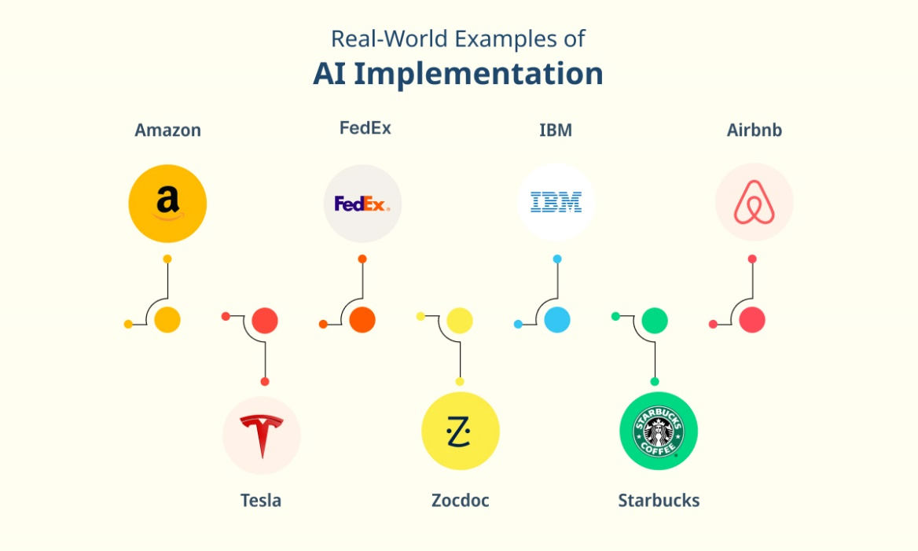

*Source: Google | Global Companies AI Implementation*

1. **AI in Customer Service**

AI-driven solutions have transformed customer service by improving response times, personalizing interactions, and increasing efficiency. **Chatbots** and **virtual assistants** are among the most common AI applications in this area. They can handle a wide range of customer queries, provide product recommendations, and even assist in troubleshooting, all while operating 24/7.

* **Automation**: AI tools such as chatbots can handle routine inquiries, allowing human representatives to focus on more complex issues.
* **Personalization**: AI can analyse customer data to deliver personalized service, leading to higher customer satisfaction and loyalty.
* **Natural Language Processing (NLP)**: AI-driven systems use NLP to understand and respond to customer queries in a human-like manner, making the interaction more seamless.

One notable example is **Amazon’s Alexa**, which enhances customer experiences by providing real-time assistance and recommendations based on user behaviour. AI in customer service not only improves user experience but also reduces operational costs.

1. **AI in Operations Management**

In operations management, AI optimizes supply chains, streamlines production processes, and automates repetitive tasks. Manufacturing companies, for instance, have benefited significantly from **robotics** and **AI-driven automation**.

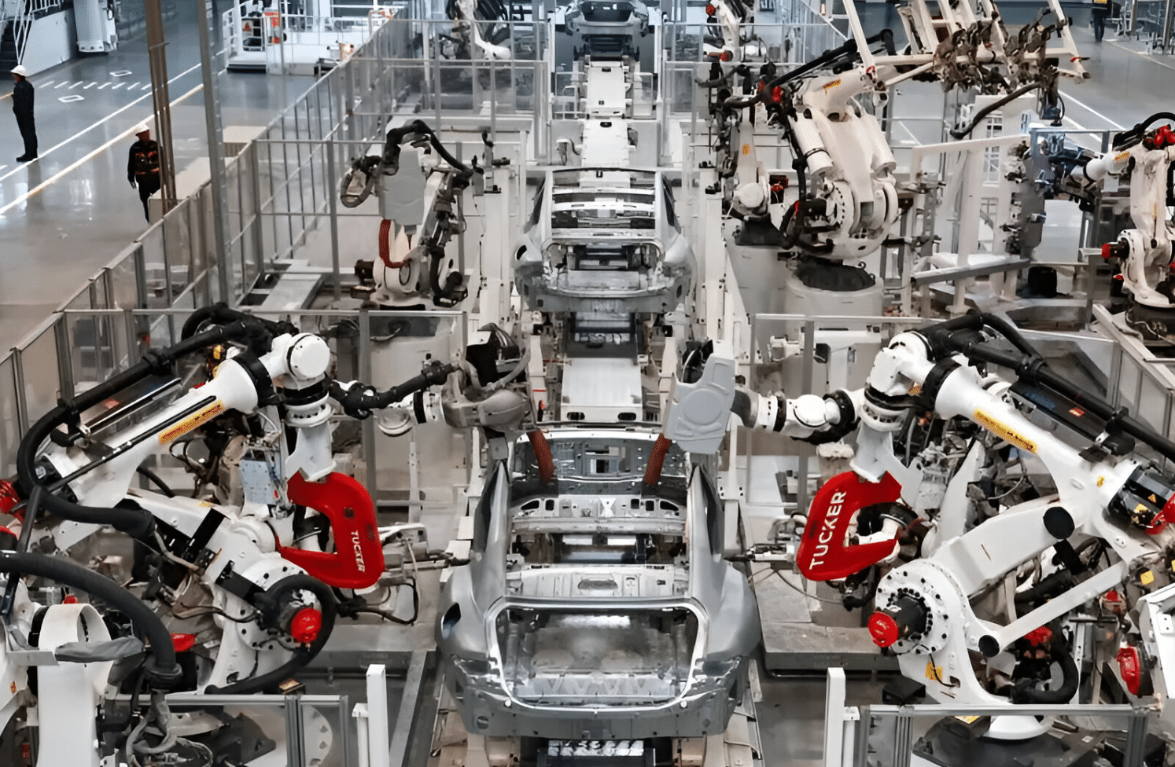

*Source: Google | A Look at the Application of Mobile Robots in the Automotive*

* **Supply Chain Optimization**: AI tools can predict demand trends, optimize inventory management, and ensure the timely delivery of goods. For example, companies like **Walmart** and **Unilever** use AI to forecast demand and adjust inventory levels.
* **Predictive Maintenance**: In industries like manufacturing and logistics, AI helps in predictive maintenance, where machines equipped with AI can identify potential failures before they occur, thereby reducing downtime and maintenance costs.
* **Automation**: Routine, repetitive tasks such as data entry, invoicing, or scheduling can be automated using AI, freeing employees to focus on higher-value activities.

AI-powered robotics are becoming a standard in industries like automotive manufacturing, where **assembly lines** are equipped with machines.

1. **AI in Data Analysis and Decision Making**

The ability of AI to analyse massive datasets in real-time has made it a game-changer for business decision-making. Traditionally, companies relied on manual data processing, which was time-consuming and prone to human error. AI’s capabilities in **Big Data analysis** and **machine learning (ML)** enable businesses to quickly identify patterns, trends, and insights that inform strategic decisions.

* **Business Intelligence**: AI algorithms can sift through complex data to extract actionable insights, helping businesses make informed decisions. For instance, AI-powered analytics tools in finance can predict stock market trends, optimize investment strategies, and detect fraudulent activities.
* **Predictive Analytics**: AI systems use historical data to predict future outcomes, which is particularly useful for marketing, sales forecasting, and customer behaviour analysis. For example, **Netflix** uses AI to recommend shows to users based on their viewing history.

1. **Global Statistics**

* **Global AI Status?**

The global Artificial Intelligence (AI) market has witnessed rapid growth over the past decade, driven by technological advancements, increased data availability, and the rising demand for automation in various industries. As of 2024, AI is no longer considered a futuristic technology; it has become an integral part of the digital transformation strategies of businesses worldwide. The global AI market is poised to continue its exponential growth, with investments across sectors such as healthcare, finance, manufacturing, retail, and education.(Google, 2024)

1. **Conclusion**

The role of AI in modern business operations is transformative, offering unparalleled opportunities for efficiency, innovation, and growth. AI is enhancing customer service through automation and personalization, optimizing operations with predictive analytics, and driving smarter decision-making. However, businesses must also navigate challenges such as ethical concerns, data privacy, and job displacement as they integrate AI technologies.

|  |  |  |
| --- | --- | --- |
| Most Common Ways Companies Are using AI | | |
| Customer Service | 2019-2024 | **90%** |
| Cybersecurity | 2022-2024 | **78%** |
| Digital Assistants | 2020-2023 | **62%** |
| Content Creation | 2019-2024 | **98%** |
| Accounting | 2022-2024 | **87%** |

*Source: Google*